`
Anish Gupta
Machine Learning for Public Informatics
1/13/2025
Exploring Walkability Through Machine Learning: A Dual Approach of Classification and Regression

Abstract
The increasing focus on sustainable urban planning has highlighted the importance of walkability in urban areas. The EPA's Walkability Index dataset provides an extensive array of variables that allow researchers to analyze and predict walkability. This project applies classification and regression techniques to predict walkability categories and specific metrics, enabling policymakers and urban planners to make informed decisions. This paper outlines the methodology, data preparation, and insights gained from both approaches.
- Introduction
Walkability can be defined as the degree to which the built environment supports walking for transportation, exercise, and leisure. It has become a focus in urban planning, public health, and environmental sustainability. Neighborhoods and urban areas are not the only indicators of urban design efficiency. Furthermore, walkability significantly influences health, social cohesion, and environmental impact. Walkable neighborhoods improve physical and mental health and foster social cohesion. Still, they also play a key role in sustainable urban growth by promoting active transportation, reducing greenhouse gas emissions, and enhancing resource efficiency. Addressing contemporary challenges like rising obesity, traffic congestion, and climate change has driven interest in walkable communities. However, realizing the potential of walkability requires a comprehensive, data-driven approach that assesses its physical and social dimensions. By leveraging advanced tools such as GIS, urban analytics, and participatory planning, policymakers and researchers can effectively identify infrastructure needs, evaluate accessibility, and implement targeted interventions. This focus on evidence-based strategies highlights walkability's power to transform cities into healthier, more inclusive, and sustainable environments. This review synthesizes academic literature and industry resources to examine its concept, determinants, and effects.
Problem Statement
Walkability, an essential aspect of urban planning and sustainable development, impacts various domains such as public health, environmental sustainability, and community livability. However, current methods for assessing walkability often rely on manual surveys, subjective interpretations, or limited datasets. These traditional approaches are time-consuming and may lack the scalability and granularity required to address the growing need for data-driven urban planning.
This project aims to predict and understand walkability using the EPA Smart Location Database, a comprehensive dataset containing diverse variables related to the built environment, employment, demographics, and accessibility. This study seeks to offer an efficient and robust methodology for walkability assessment by leveraging predictive modeling techniques such as Random Forest and Gradient Boosting. The proposed model simplifies the evaluation process and identifies key factors influencing walkability, enabling urban planners and policymakers to make more informed decisions.
Objectives
This project addresses the challenges of evaluating walkability by leveraging data-driven strategies. Some of the specific objectives include:
Developing a predictive solution: Utilizing machine learning methods to create a robust and scalable predictive model to estimate the National Walkability Index (NatWalkInd) using the variables provided in the EPA Smart Location Database.
Identifying key influencing features: The predictive model will determine the most critical factors that impact walkability in New Jersey. Understanding these relationships is essential and will help urban planners and policymakers prioritize areas for intervention and resource allocation.
Classifying walkability: Geographic areas will be categorized into distinct levels of walkability based on the predicted values of the NatWalkInd. This classification will enable a better understanding of patterns in walkability and provide actionable insights for targeted urban improvements.
Dataset and Study Area
This machine-learning project utilizes the EPA Smart Location Database (SLD), a comprehensive dataset developed by the U.S. Environmental Protection Agency. The study focuses specifically on New Jersey, chosen for its urban diversity, ranging from densely populated metropolitan areas to suburban and rural landscapes. In addition, New Jersey is home to Rutgers University. Furthermore, New Jersey’s policy emphasis on sustainability, smart growth, and improving public transportation systems is associated with the goals of this project, making it a highly relevant area for exploring improvements in walkability.
Methodology Overview
Some methods used in this project include data preprocessing, feature selection, model development, and evaluation. In addition, the machine-learning algorithms explored in this project were Decision Trees, Random Forests, and Gradient Boosting.

2. Literature Review: Walkability and Its Implications on Urban Design, Public Health, and Sustainability
Walkability can be defined as the degree to which the built environment supports walking for transportation, exercise, and leisure. It has become a focus in urban planning, public health, and environmental sustainability. Neighborhoods and urban areas are not the only indicators of urban design efficiency. Furthermore, walkability significantly influences health, social cohesion, and environmental impact. This review synthesizes academic literature and industry resources to examine its concept, determinants, and effects.
Conceptualizing Walkability
The concept of walkability extends beyond physical infrastructure to include social factors. A BMC Public Health article argues that safety, aesthetics, and sidewalks and crosswalks influence population-level walking behaviors. According to BMC Public Health, walkability involves elements of the built and social environments that support pedestrian activity at the population level, such as well-maintained sidewalks, safety, and aesthetic appeal (BMC Public Health, 2022). The Tennessee Department of Health similarly emphasizes the role of walkable neighborhoods in promoting active transportation and community building. Similarly, the Tennessee Department of Health defines walkable neighborhoods as those promoting health through active transportation and community cohesion (Tennessee Department of Health, n.d.). Both definitions highlight the interconnectedness of physical design and community engagement in creating walkable environments.
Health Benefits of Walkability
Walkable environments can improve public health outcomes, which connects to a significant body of research. According to the BMC Public Health, lower mortality rates and non-communicable disease rates in more walkable areas. A systematic review by BMC Public Health identifies reductions in mortality rates and non-communicable diseases as direct results of improved walkability (BMC Public Health, 2023). These findings are verified by the International Journal of Environmental Research and Public Health, which relates greater walkability levels to increased physical activity and diminished obesity rates. Another study by the International Journal of Environmental Research and Public Health links walkability to increased physical activity, reduced obesity rates, and decreased BMI levels (International Journal of Environmental Research and Public Health, 2023). Research from Boston University shows that well-designed urban environments encourage walking with direct benefits for BMI and fitness. This evidence reinforces the importance of walkability for physical health and disease prevention. Furthermore, research from Boston University emphasizes the relationship between walkable neighborhoods and physical fitness, showing that higher walkability levels encourage walking and reduce sedentary behaviors (Boston University School of Public Health, 2023).
Urban Design and Sustainability
Walkability has an important role to play when it comes to advancing towards sustainable urban design. Frontiers in Built Environment states that incorporating walkability into urban planning promotes health and mitigates urban sprawl by prioritizing pedestrian-friendly spaces over automobile-centric infrastructure (Frontiers in Built Environment, 2021). Planetizen and Walk Score further emphasize the importance of mixed-use developments, street connectivity, and accessible amenities in fostering walkable urban areas (Planetizen, n.d.; Walk Score, n.d.). Walkability promotes walking as a primary mode of transportation, reduces greenhouse gas emissions, and supports environmentally sustainable cities. It can also offer significant health benefits, further justifying its prioritization in urban design.
Social Impacts of Walkability
In addition to its physical and environmental benefits, walkability strengthens social cohesion and community well-being. According to the International Journal of Environmental Research and Public Health, they revealed that pedestrian-friendly neighborhoods promote neighborly interactions and community engagement, thereby enhancing social health (International Journal of Environmental Research and Public Health, 2023). This finding aligns with research from Walk Score, which identifies well-connected streets as crucial for facilitating multimodal transportation and fostering a sense of belonging (Walk Score, n.d.). These social benefits reveal walkability’s comprehensive role in improving the overall quality of life in urban areas.
Optimization and Technology in Walkability
Technology and data analytics have significantly improved walkability optimization. An arXiv study presents models for enhancing walkability through optimized amenity access, using Toronto as a case study (arXiv, 2022). A Scientific Reports visualization analysis explores using big data and GIS for monitoring and enhancing urban walkability (Scientific Reports, 2024). These innovations highlight the increasing integration of technology and urban design to maximize walkability’s benefits.
Limitations and Future Directions
While advantageous, walkability is challenged by inequitable distribution, urban sprawl, and safety concerns. A Transport Reviews review (2022) also highlights the influence of demographics and individual needs on walkability perceptions.
- Data
The SLD integrates spatial, demographic, and transportation-related variables for analyzing urban and regional planning patterns. Some of the variables in the SLD include:
D4A_Ranked: Metrics capturing land use diversity and access.
D3B_Ranked: Measures of pedestrian-oriented design.
D4D: Indicators of destination accessibility.
D5BE: Working age population within 45-minute transit commute, time decay (walk network travel time, GTFS schedules)
Pct_AO0: Proportion of zero-auto households.
D1A: Gross residential density (HU/acre) on unprotected land
These variables, among others, are essential for developing predictive models and understanding the factors influencing walkability.
Exploratory Data Analysis
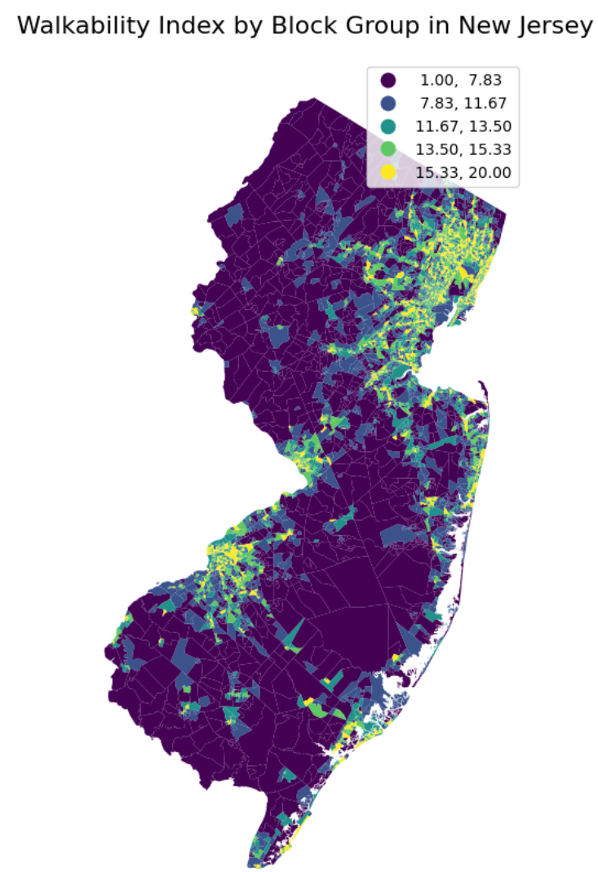

As part of the exploratory data analysis, I created a map that visualizes the distribution of the National Walkability Index (NatWalkInd) across block groups in New Jersey, using a gradient scale to indicate different levels of walkability. The map provides insights into spatial patterns highlighting higher or lower walkability regions.
- Highest Walkability Areas (shaded in yellow and light green)

The areas with the highest walkability scores (15.33–20.00) are concentrated around urban and densely populated regions. High walkability in these areas may be attributed to higher residential density, proximity to amenities, and robust public transportation networks.

- Moderate Walkability Areas (shaded in green and light blue)
Moderately walkable regions (11.67–15.33) appear in suburban zones or smaller urban centers. Some of these areas have mixed-use development and access to walkable infrastructure, although they may lack the density or connectivity of urban cores.
- Low Walkability Areas
Low walkability scores (1.00–7.83) dominate rural and less developed areas, especially in the southern and northwestern parts of the state. These regions have lower population density, limited access to amenities, and car-dependent transportation patterns.
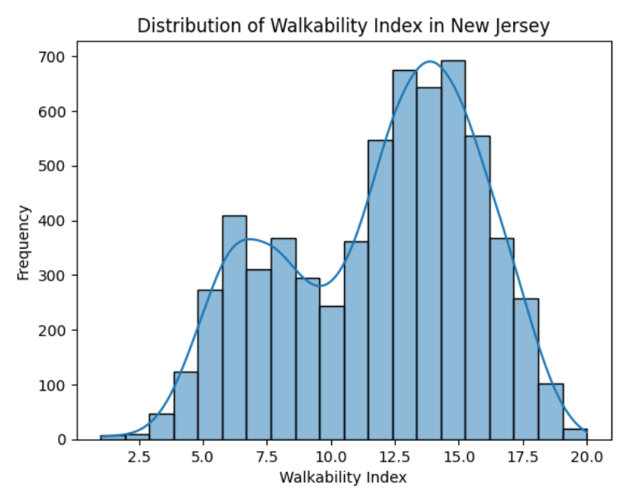
The above histogram displays the frequency distribution of the National Walkability Index (NatWalkInd) using a smoothed density curve to represent data from New Jersey block groups.
1. Distribution Shape
The index shows an approximately normal distribution around 13.0 to 15, indicating that most block groups have moderate walkability. The scores range from 2.5 to 20.0, with a few areas scoring very low (<7.5) or very high (>18).
2. Insights
Suburban and semi-urban development patterns are reflected in the dominance of moderate walkability. Areas with lower scores (<7.5) may need targeted interventions to improve walkability.
3. Policy Relevance
The results suggest balanced walkability but highlight opportunities to enhance equity by addressing low-scoring areas.
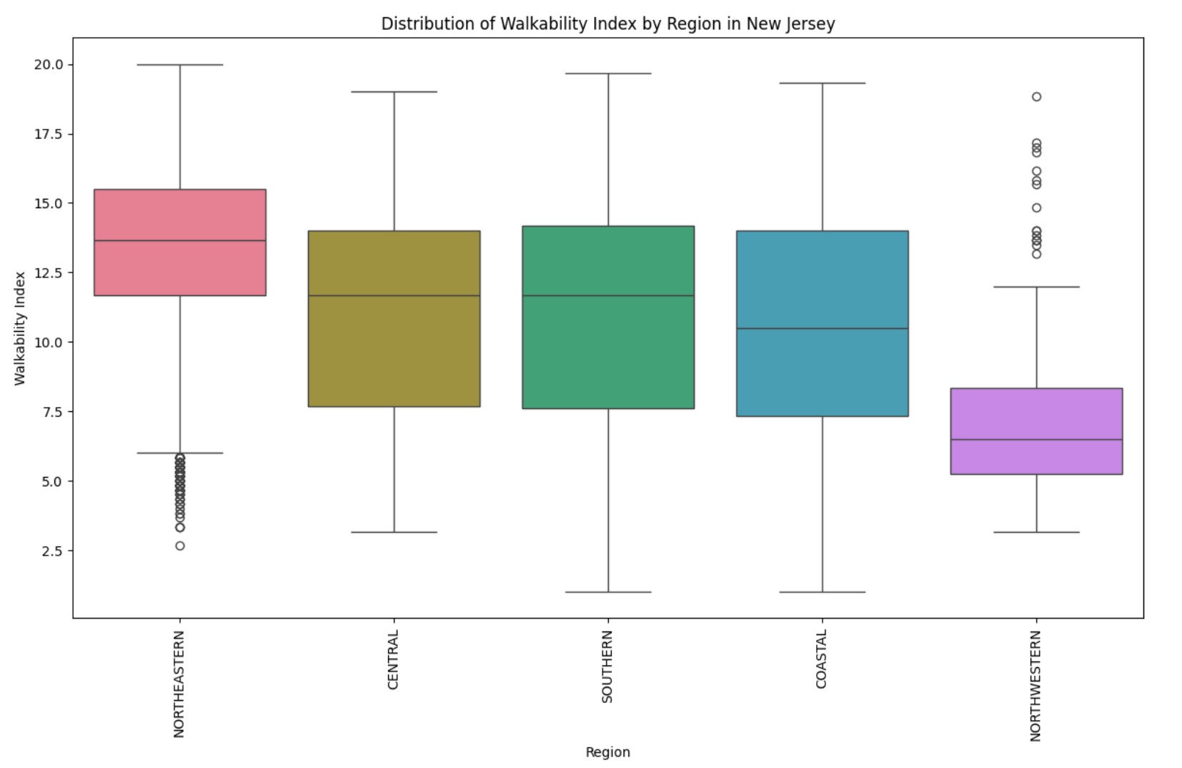
The boxplot shows the distribution of the National Walkability Index (NatWalkInd) across five regions in New Jersey: Northeastern, Central, Southern, Coastal, and Northwestern.
1. Regional Trends
Northeastern: Highest median walkability (~14) with outliers below 7.5, indicating urban centers with some low-scoring areas.
Northwestern: Lowest median walkability (~10), with a smaller range and no high scores, reflecting rural characteristics.
Central, Southern, and Coastal: Similar median scores (~12.5–13), with wider ranges, indicating mixed urban and suburban developments.
2. Insights
Walkability varies significantly by region, with the Northeastern region being the most walkable and the Northwestern region the least.
Distribution in coastal and suburban areas is more balanced, with fewer extreme values.
3. Policy Implications
To improve walkability, efforts might focus on rural (Northwestern) and low-scoring suburban areas in Northeastern New Jersey.
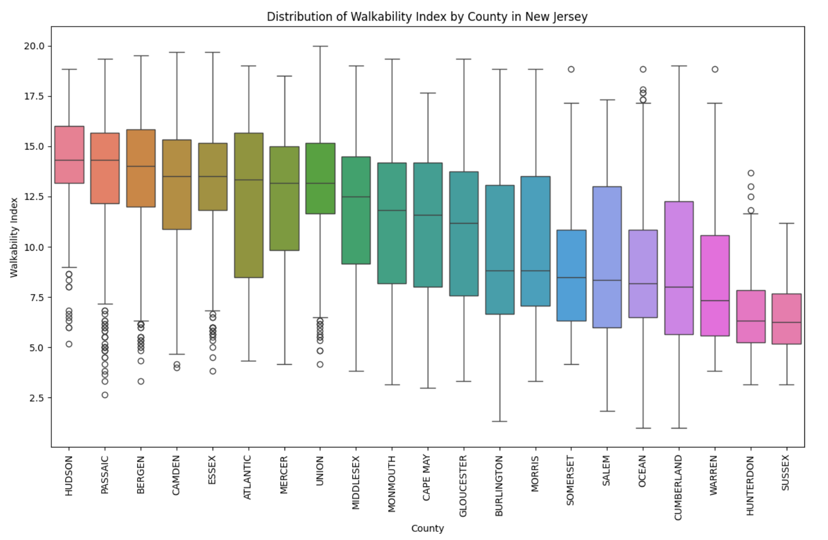

This boxplot shows a significant variation in walkability across New Jersey counties. It can be noticed that some counties have higher median walkability scores, indicating better overall walkability. Some urban counties, such as Hudson, Essex, and Union, reveal higher median walkability scores, suggesting more walkable environments. On the contrary, rural counties such as Warren, Hunterdon, and Sussex appear to have lower median scores, implying greater dependency on car usage. Urban areas show more significant within-county variability in walkability, while rural counties show more consistent and lower scores. There is an unevenness of walkability across New Jersey, and urbanization influences the levels of walkability. Some outliers indicate areas with exceptionally high or low walkability within certain counties.
- Data Preprocessing
Data Preprocessing
First, I checked which columns had missing values and how many were in the SLD. I decided to drop the columns CSA (Combined Statistical Area Code), CSA_Name (Name of CSA in which CBG resides), CBSA (FIPS for Core-Based Statistical Area in which CBG resides), and CBSA_Name (Name of CBSA in which CBG resides) with a high number of missing values as they would not be used in the analysis. Next, missing values for D1A (Gross residential density (HU/acre) on unprotected land), CountHU (Housing units, 2018), and HH (Households occupied housing units, 2018) were handled using multivariate imputation. Next, the dataset was filtered for New Jersey.
Feature Selection
Correlation analysis was performed to identify features strongly correlated with the NatWalkInd (Walkability Index) variable. The initial features selected had a high correlation with NatWalkInd and sometimes with each other.

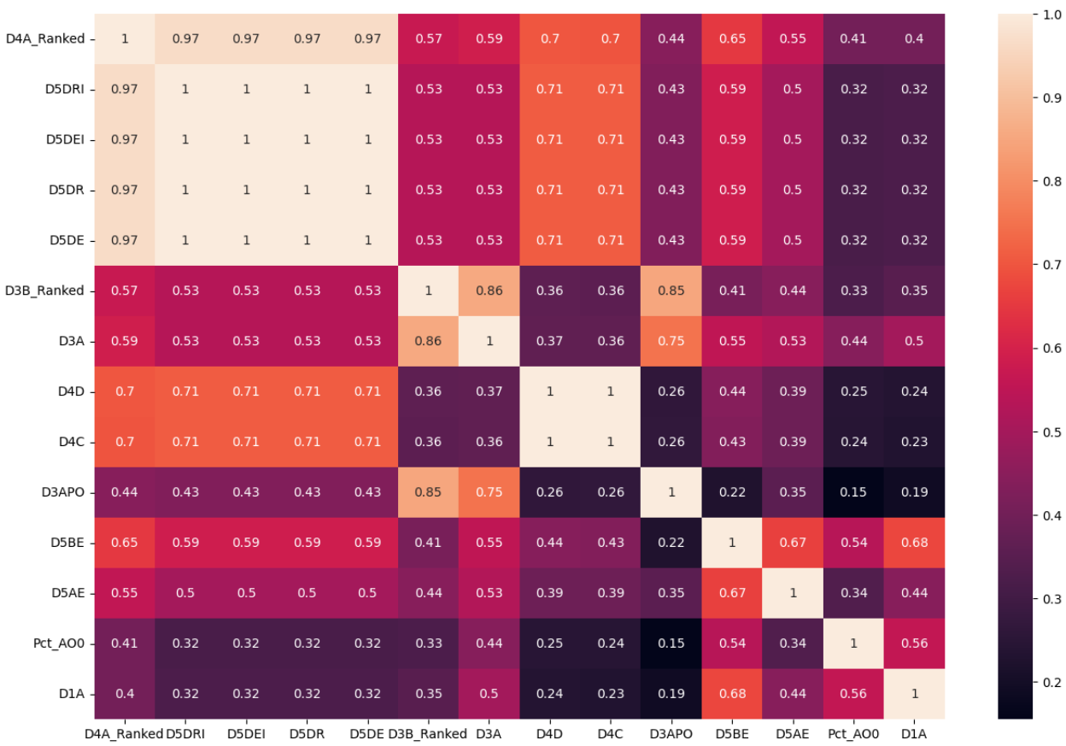

After a few iterations, "D5DRI", "D5DEI", and "D5DR" were dropped due to high multicollinearity and a close association with other variables. Dropping these variables led to a huge improvement in the correlation matrix. However, checking for VIFs displayed high multicollinearity for some of the features.

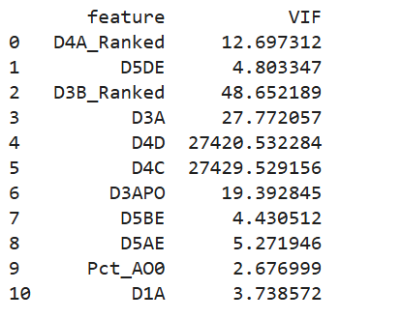
After further refinement, the features selected are listed below, displaying the correlation with the walkability index and descriptions as follows:
- D4A_Ranked (0.8689) - Quantile ranked order (1,13-20) of [D4a] from lowest to highest where D4A is the distance from the population-weighted centroid to nearest transit stop (meters)
  - Strongest correlation with NatWalkInd among all features.
- D3B_Ranked (0.7217) - Quantile ranked order (1-20) of [D3b] from lowest to highest where D3B is the street intersection density (weighted, auto-oriented intersections eliminated)
  - High correlation and likely unique in relation to walkability.
- D4D (0.6314) - Aggregate frequency of transit service [D4c] per square mile
  - High correlation and complements other selected features.
- D5BE (0.5642) - Working age population within 45-minute transit commute, time decay (walk network travel time, GTFS schedules)
  - Relates to the built environment and land-use mix, contributing to walkability.
- Pct_AO0 (0.3539) - Percent of zero-car households in CBG, 2018
  - Though weaker, it represents auto ownership, which might be inversely related to walkability.
- D1A (0.321318) - Gross residential density (HU/acre) on unprotected land
  - Though weaker, it represents gross residential density, it might be positively associated with walkability.
Here are the refined correlation matrix and the VIF.

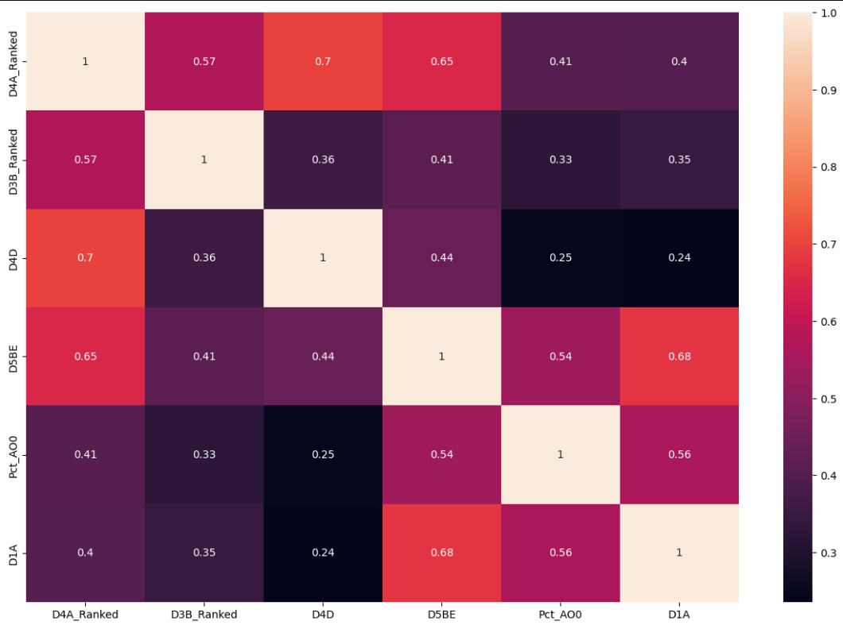
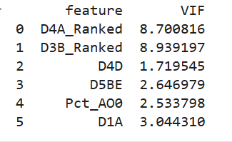
Although features were carefully selected to minimize multicollinearity, some of the features still had high collinearity among themselves.
- Machine Learning Model Pipeline Design
Machine Learning using Regression to predict Walking Index
First, the data was split into training (80%) and testing (20%) subsets for evaluation with a random state of 0. Tree-based models like Decision Trees, Random Forest, and Gradient Boosting were mostly selected as the selected features displayed some collinearity, and these models are not highly sensitive to correlations between features. One of the major advantages of the tree-based model is that it requires very little data preprocessing compared with linear and regularized linear models. However, linear regression has also been used for comparison purposes. R² has been used as the model evaluation metric as it is a simple and interpretable relative measure of fit and is used to compare multiple models.
Decision Trees
The decision tree was used to create a model that predicts the value of the walkability index by implementing simple decision rules inferred from the data features. First, a default decision tree was used, and the best R² was 0.69 with a standard deviation of +/- 0.06. Next, the decision tree was fine-tuned, and the parameters used were - max_features: sqrt and min_samples_leaf': 14. The average R² across 10 folds for the best parameter was 0.81 with a standard deviation of +/-0.02.
Linear Regression
A multiple linear regression model was used, and the value of R² was 0.84 with a standard deviation of +/- 0.02
Random Forest
A Random Forest Regressor was used to predict the value of the walkability index. A default Random Forest Regressor was used, and the best R² was 0.83 with a standard deviation of +/-0.03. After that, the Random Forest Regressor was fine-tuned, and the parameters used were min_samples_leaf: 6, n_estimators: 140, and max_features: 6. The average R² across 10 folds for the best parameter was 0.84 with a standard deviation of 0.02. This was an improvement over the default model.
Gradient Boosting
A Gradient Boosting Regressor was used to predict the value of the walkability index. The default Gradient Boosting Regressor was used, and the R² was 0.85 with a standard deviation of +/- 0.02. The Gradient Boosting Regressor was fine-tuned using hyperparameter optimization with sckit-optimize package. The best score was -0.8465. The best parameters that were used to fine-tune the Gradient Boosting Regressor were n_estimators = 100, max_depth = 5, learning_rate = 0.085883, max_features = 2, and min_samples_split = 150. After including these parameters, the R² was 0.85 with a +/- 0.02 standard deviation.
Machine Learning for Classifying Walkability
For the classification, bins were created, and the data was split into training and testing subsets for evaluation. After that, the data was checked to see if it was balanced. For this, a continuous variable named NatWalkInd – walkability index is divided into categories: “Very Low," "Low," "Medium," and "High." It does this by creating ranges based on the bins and assigning labels from labels. The result is a new column in the dataframe called "WalkabilityCategory" that contains these category labels for each data point.
To check if the data is balanced, unique counts for WalkabilityCategory were generated

WalkabilityCategory | Count
Medium | 2328
Low | 1373
High | 1134
Very Low | 221

As the data was not balanced, data balancing was performed using the upsampling technique. The walkability category counts after upsampling were:
WalkabilityCategory | Count
Medium | 2328
Low | 2328
High | 2328
Very Low | 2328

Random Forest Classifier
First, a default Random Forest Classifier was used. Then the Random Forest Classifier was fine-tuned, and the best parameters were max_depth: 10, min_samples_leaf: 2, min_samples_split: 10, n_estimators: 20. The scoring was set to f1_macro.
Gradient Boosting Classifier
First, a default Gradient Boosting Classifier was used. After that, a default Gradient Boosting Classifier was used. The Gradient Boosting Classifier was fine-tuned, and the best parameters that were used were max_depth': 10, 'min_samples_leaf': 1, 'min_samples_split': 10, 'n_estimators': 80. For the Gradient Boosting Classifier, the scoring was set to f1_macro.

- Machine Learning Results
Regression
Linear regression was used to check the model performance on the testing set. The model R² score for linear regression is 0.818. Next, the model performance on the testing set was used with Random Forest. The R² score for Random Forest is 0.825. After that, Gradient Boosting was used to check the model performance on the testing set. The R² score for Gradient Boosting is 0.834. For regression, out of all the models, the best model was Gradient Boosting with an R² value of 0.834.
Classification
For the default Random Forest Classifier, the accuracy score was 0.753, the precision score was 0.756, and the recall score was 0.753. The best F1-score for the fine-tuned Random Forest Classifier was 0.848. After passing the best parameters, the prediction for the Random Forest Classifier did not improve and slightly decreased. The accuracy score was 0.723, the precision score was 0.720, and the recall score was 0.723. These results show that the default Random Forest Classifier performed better than the fine-tuned Random Forest Classifier.
For the default Gradient Boosting Classifier, the accuracy score was 0.703, the precision score was 0.707, and the recall score was 0.703. After passing the best parameters, the predicted accuracy score was 0.702, the predicted precision score was 0.704, and the predicted recall score was 0.702. The results show that the default Gradient Boosting Classifier performed better than the fine-tuned Gradient Boosting Classifier.
Overall, for classification, the default Random Forest Classifier produced the best results in terms of classifying areas in terms of walkability categories of very low, low, medium, and high.

Confusion matrix Random Forest Classifier
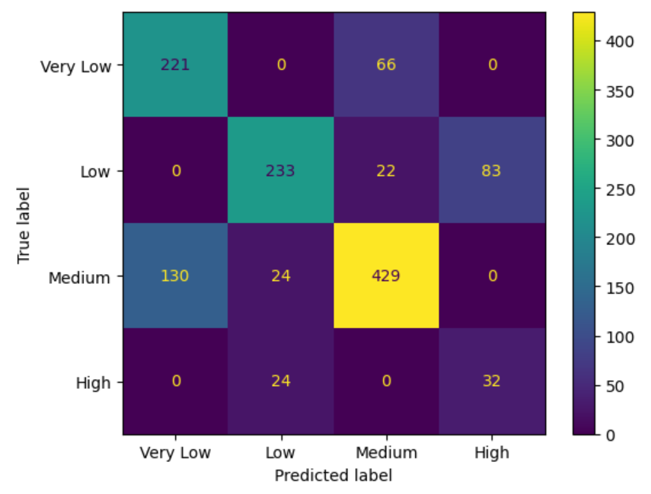
The confusion matrix Random Forest Classifier model performs well in predicting Medium and Low categories regarding the relatively high diagonal values 429 and 233. The Very Low predictions are accurate for the most part, with 221 correct predictions and fewer misclassifications. Regarding weaknesses, the confusion matrix Random Forest Classifier model has 130 Medium instances predicted as Very Low. This indicates potential confusion in distinguishing between Medium and Very Low. Only 32 instances were correctly classified as High, while 24 were incorrectly classified as Low.

Confusion matrix Gradient Boosting Classifier
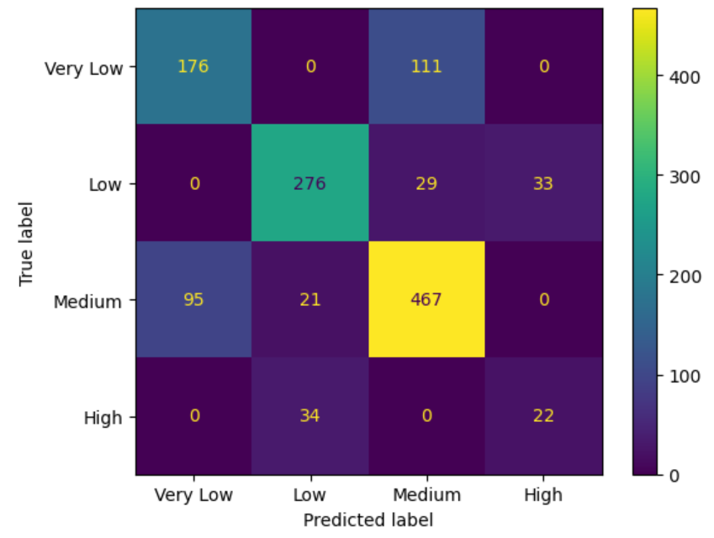
The confusion matrix Gradient Boosting Classifier model performs well in predicting Medium and Low categories regarding the relatively high diagonal values 467 and 276. The Very Low predictions are accurate for the most part, with 176 correct predictions and fewer misclassifications. Regarding weaknesses, the confusion matrix Gradient Boosting Classifier model has 95 Medium instances that were predicted as Very Low. This indicates potential confusion in distinguishing between Medium and Very Low. Only 22 instances were correctly classified as High, while 34 were incorrectly classified as Low.
- Interpretable Machine Learning
Decision Tree

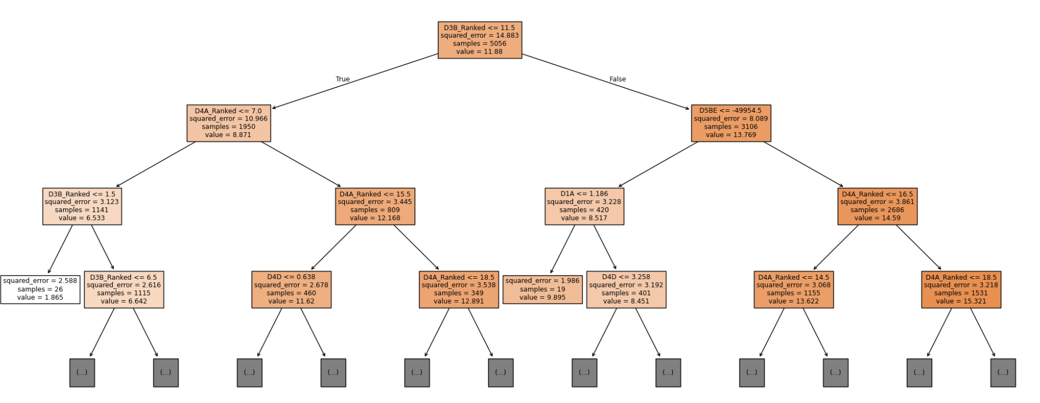
Features like D4A_Ranked, D3B_Ranked, and D5BE appear frequently at decision tree splits, suggesting they are significant in predicting the target variable. The tree progressively splits the data into smaller subsets, reducing squared error and providing more precise predictions for subsets. There is an imbalance in the data splits. Certain nodes, like the right side of D3B_Ranked <= 11.5, handle significantly more samples than others. This indicates where the model focuses more.
Random Forest Ranked List of Most Important Features
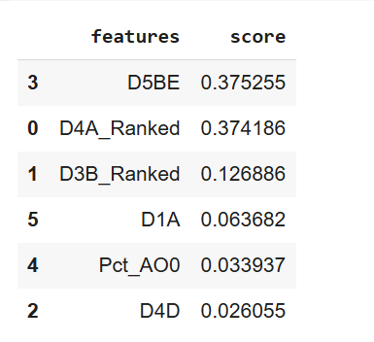
D5BE (Working age population within 45-minute transit commute, time decay), D4A_Ranked (Quantile ranked order (1,13-20) of [D4a] from lowest to highest where D4A is the distance from the population-weighted centroid to nearest transit stop (meters)) and D3B_Ranked (Quantile ranked order (1-20) of [D3b] from lowest to highest where D3B is the street intersection density (weighted, auto-oriented intersections eliminated)) are the most important features for predicting the Walkability Index
Overall, D5BE, D4A_Ranked, and D3B_Ranked are the most important features for predicting the Walkability Index. Therefore, factors like the working-age population within a 45-minute transit commute, the distance from the population center to the closest transit stop, and the street intersection density are vital in determining walkability irrespective of the methods used. In addition, features like frequency of transit, percentage of households without cars, and residential density are also helpful in predicting walkability.
In addition, a classification machine learning model like the Random Forest Classifier helps classify areas into very low, low, medium, and high walkability categories. This allows policymakers to determine which block groups are very low or low in walkability and target them for improving walkability.
- Conclusion
This study demonstrates the potential of leveraging machine learning techniques to evaluate and predict walkability across diverse urban and suburban environments in New Jersey. By applying classification and regression models to the EPA Smart Location Database, the key determinants of walkability have been identified, including transit accessibility, intersection density, and residential density. Among the methods explored, Gradient Boosting provided the most accurate predictions, highlighting its suitability for analyzing complex, interrelated urban factors.
The findings underscore the significant role of data-driven approaches in enhancing urban planning and sustainability. The exploratory data analysis shows that the Northwestern region of New Jersey has the lowest median walkability index. Ocean, Cumberland, Warren, Hunterdon, and Sussex counties have the lowest median walkability index. Using a classification machine learning model such as the Random Forest Classifier can be beneficial in classifying areas into walkability categories of very low, low, medium, and high. Policymakers should focus more on these areas to improve walkability. The insights gained can guide policymakers in targeting low-walkability areas, optimizing resource allocation, and promoting equitable urban development. Future research should address the limitations of this study, including incorporating more granular socioeconomic data and advanced spatial analytics to create even more nuanced and actionable models.
In conclusion, integrating machine learning into urban informatics provides a powerful framework for fostering healthier, more sustainable, and more inclusive cities. By advancing predictive capabilities and prioritizing walkability as a core metric, urban planners can effectively address contemporary challenges and improve the quality of life for diverse communities. Future research should focus on tailored solutions and the integration of walkability into sustainable and resilient urban development frameworks. Walkability, a multifaceted concept with profound implications for urban planning, public health, and environmental sustainability, promotes physical activity, reduces chronic disease risks, fosters social interaction, and supports sustainable urban growth. As cities confront climate change and public health crises, enhancing walkability remains crucial for creating healthier, more livable, and equitable urban spaces.

Sources:
• Althoff, T., Ivanovic, B., Hicks, J. L., Delp, S. L., King, A. C., & Leskovec, J. (2024). Countrywide natural experiment reveals impact of built environment on physical activity. Retrieved from https://arxiv.org/abs/2406.04557
• Baobeid, A., Koç, M., & Al-Ghamdi, S. G. (2021). Walkability and its relationships with health, sustainability, and livability: Elements of physical environment and evaluation frameworks. Retrieved from https://www.frontiersin.org/journals/built-environment/articles/10.3389/fbuil.2021.721218/full
• De Vos, J., & Lättman, K. (2022). Determinants and effects of perceived walkability: A literature review, conceptual model and Research Agenda. Retrieved from https://www.tandfonline.com/doi/full/10.1080/01441647.2022.2101072
• Huang, W., & Khalil, E. B. (2022). Walkability optimization: Formulations, algorithms, and a case study of Toronto. Retrieved from https://arxiv.org/abs/2212.05192
• Li, X., Xie, D., Zhou, Z., Zhang, X., Li, R., Li, J., … Zhang, J. (2024). Visualization analysis of research progress for Walkability. Retrieved from https://www.nature.com/articles/s41598-024-52227-9
• Morris, V. (2023). US neighborhood walkability influences physical activity, BMI Levels. Retrieved from https://www.bu.edu/sph/news/articles/2023/us-neighborhood-walkability-influences-physical-activity-bmi-levels/
• Rourk, A. (2021). Smart Location Database. Retrieved from https://edg-epa.hub.arcgis.com/datasets/f6c5aa0e77ee4c5da35893720007b55f_0/explore
• Soeharjono, D. (2025). What is Walkability? | planetizen planopedia. Retrieved from https://www.planetizen.com/definition/walkability
• Tobin, M., Hajna, S., Orychock, K., Ross, N., DeVries, M., Villeneuve, P. J., … Fuller, D. (2022). Rethinking walkability and developing a conceptual definition of active living environments to guide research and Practice - BMC Public Health. Retrieved from https://bmcpublichealth.biomedcentral.com/articles/10.1186/s12889-022-12747-3
• Walkability. (n.d.). Retrieved from https://www.tn.gov/health/cedep/environmental/healthy-places/healthy-places/active-transportation/at/walkability.html#:~:text=Walkable%20neighborhoods%20can%20improve%20health,%2C%20work%2C%20exercise%20or%20relaxation
• Walkable neighborhoods. (2025). Retrieved from https://www.walkscore.com/walkable-neighborhoods.shtml
• Wang, M. L., Narcisse, M.-R., & McElfish, P. A. (2023). Higher walkability associated with increased physical activity and reduced obesity among United States adults. Retrieved from https://pmc.ncbi.nlm.nih.gov/articles/PMC9877111/
• Westenhöfer, J., Nouri, E., Reschke, M. L., Seebach, F., & Buchcik, J. (2023). Walkability and urban built environments-A systematic review of Health Impact Assessments (HIA) - BMC public health. Retrieved from https://bmcpublichealth.biomedcentral.com/articles/10.1186/s12889-023-15394-4
• Zhu, X., Lu, Z., Yu, C.-Y., Lee, C., & Mann, G. (2013). Walkable communities: Impacts on residents’ physical and Social Health: Researchers from Texas A&M University studied residents in a newly developed “Walkable Community” in Austin, Texas to see how it changed their habits for physical activity and whether it increased social interaction and cohesion in the community. Retrieved from https://pmc.ncbi.nlm.nih.gov/articles/PMC8776244/

